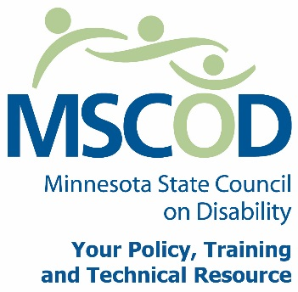

Full Council Meeting Agenda, October 18, 2012
DS Event Center, 415 Pascal Street North, Saint Paul, MN 55104
9:00 a.m. to 11:30 am
8:30: Breakfast
9:00: Call to order and Introductions
9:05: ACTION: Approval of Agenda and ACTION: Approval of Minutes
9:10: Subcommittee Reports
- 9:10:Access Committee with Mark Hughes and Margot
- 9:20: Employment Committee with Colin and Kathy/Joani
- 9:30: Events Committee with Dean and Tricia
9:35: State Fair Update with Colin Stemper
9:40: Customer Satisfaction Survey with Colin Stemper
9:50: MNET Transportation Update, Noel Shugart
10:10: Break
10:20: Strategic Planning Update with Joan Willshire
10:30: Update on Bullying, Prone Restraint and Education Gaps with Kim Kang
10:50: Chair’s Report with Dave Schwartzkopf
10:50: Executive Director’s Report with Joan Willshire
11:10: ACTION: Budget
- PTE monies, $5000 extra in PTE monies, Encumbrances, Blanket POs
11:20: Appreciation for Antony
11:25: Adjourn
11:30:Lunch

