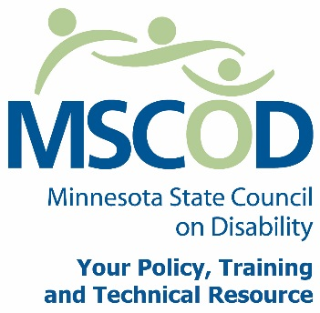

MSCOD Council Meeting Agenda, Wednesday, June 5, 2013
Golden Rule Building, Room 295
85 E 7th Place, Saint Paul, MN 55101
12:30 p.m. to 3:00 pm
12:30 p.m.: Call to order and Introductions
ACTION: Approval of Agenda and ACTION: Approval of Minutes
12:40 p.m.: Rebecca Covington – MN-CCD (15 mins)
12:55 p.m.: Legislative Update from Colin (10 mins)
1:10 p.m.: Legacy Funds (10 mins)
1:20 p.m.: Questions and Answers (10 mins)
1:30 p.m.: Break (10 mins)
1:40 p.m.: Review of last year’s strategic goals and work plan (5 min)
1:45 p.m.: 2014 – 2015 work plan (1 hour, 15 mins)
3:00 p.m.: Adjourn
This document is also available in accessible formats.

