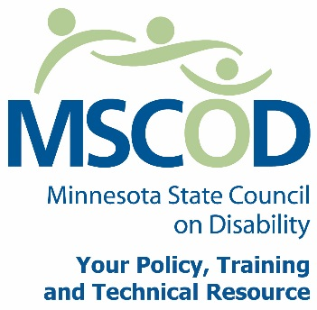

MSCOD Council Meeting Agenda, Thursday, October 17, 2013
DS Event Center
415 Pascal St. N, Saint Paul, MN 55104
9:00 a.m. to 11:30 a.m.
8:30 a.m.: Continental breakfast.
9:00 a.m.: Call to order and Introductions (5 min).
ACTION: Approval of Agenda and ACTION: Approval of Minutes
9:05 a.m.: Subcommittee reports (30 min).
Access
Employment
Events-ACTION: Approval Legacy Budget
9:35 a.m.: Proposed by law changes discussion/action (15 min).
9:50 a.m.: State fair survey review (10 min).
10:00 a.m.: Annual satisfaction survey review (15 min).
10:15 a.m.: Financial report- Approval Encumbrance FY14 Blanket Order (10 min).
10:25 a.m.: Chairs report (5 min).
10:30 a.m.: Executive Director report (5 min).
10:35 a.m.: BREAK (10 min)
10:45 a.m.: MNSure presentation and Q/A (35 min).
11:20 a.m.: Public comments (5 min).
11:25 a.m.: Other (5 min).
11:30 a.m.: Adjourn
11:30 a.m.: Lunch at DS EVENT CENTER (45 min).
12:30 p.m.: Guests start arriving, Council welcomes guests.
1:00 p.m.: Event starts.
Next Council meeting: January 23, 2013. Hiway Federal Credit Union St. Paul
This document is also available in accessible formats.

