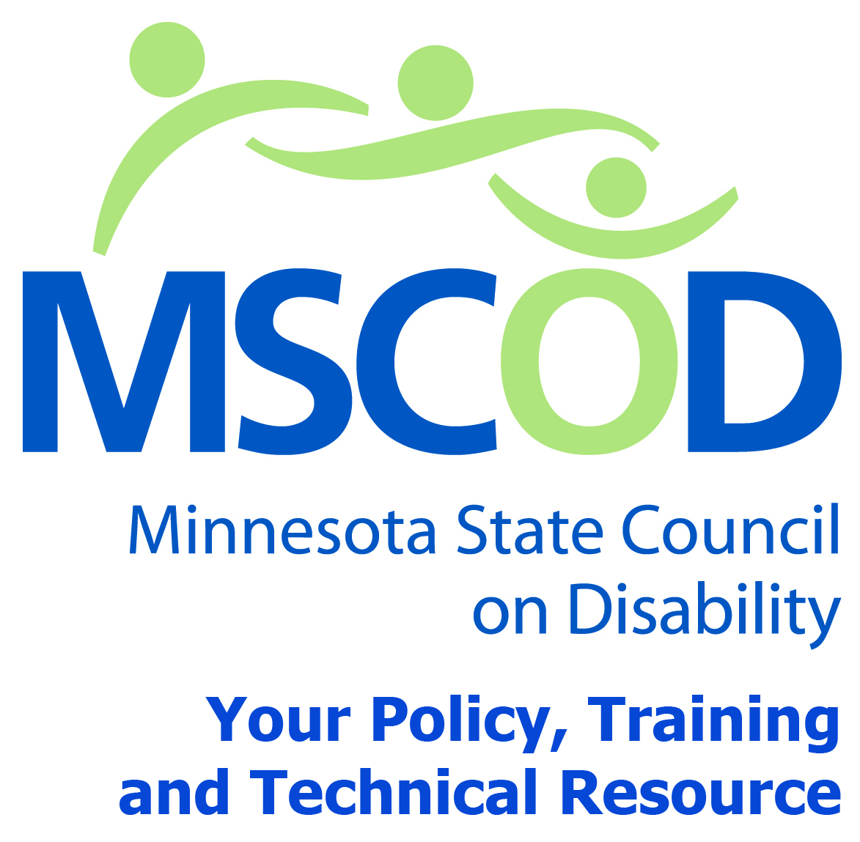

MSCOD Council Meeting Agenda
Friday, September 26, 2014
121 East 7th Place Saint Paul, MN 55101
9:00 a.m. to 2:30 p.m. Metro Square-Lower Level Room 2
9:00 a.m.: JOINT-Subcommittee Meetings (60 minutes).
Olmstead updates by Kristine Jorenby, Olmstead Implementation Office.
HCBS waiver update Heidi Hamilton, Dept. of Human Services
10:00 a.m.: BREAK (15 minutes).
10:15 a.m.: Home Community Based Services Speaker-Sean Burke, MN Disability Law Center focus group discussion (60 minutes).
11:15 a.m.: Employment discussions with Jon Alexander and Don Lavin from Employment First Coalition (20 minutes).
EO-14-14 Speaker Anne Feaman, State MN ADA Coordinator (20 minutes).
Employment First Collation DISCUSSION (20 minutes).
12:15 p.m.: LUNCH (45 minutes).
1:00 p.m.: Call to order and Introductions (5 minutes).
ACTION: Approval of Agenda and ACTION: Approval of Minutes
1:05 p.m.: Annual satisfaction survey review (15 minutes).
1:20 p.m.: MSCOD Legislative discussion (15 minutes).
1:35 p.m.: Sub-committee reports (25 minutes).
Accessibility
Employment
Events
ADA 25th anniversary event update
2:00p.m.: Public comment (5 minutes).
2:05 p.m.: BREAK (10 minutes).
2:10 p.m.: Chairs report (20 minutes).
Executive Director’s report
Budget approval
Other
2:30 p.m.: Adjourn
This document is also available in accessible electronic formats.

