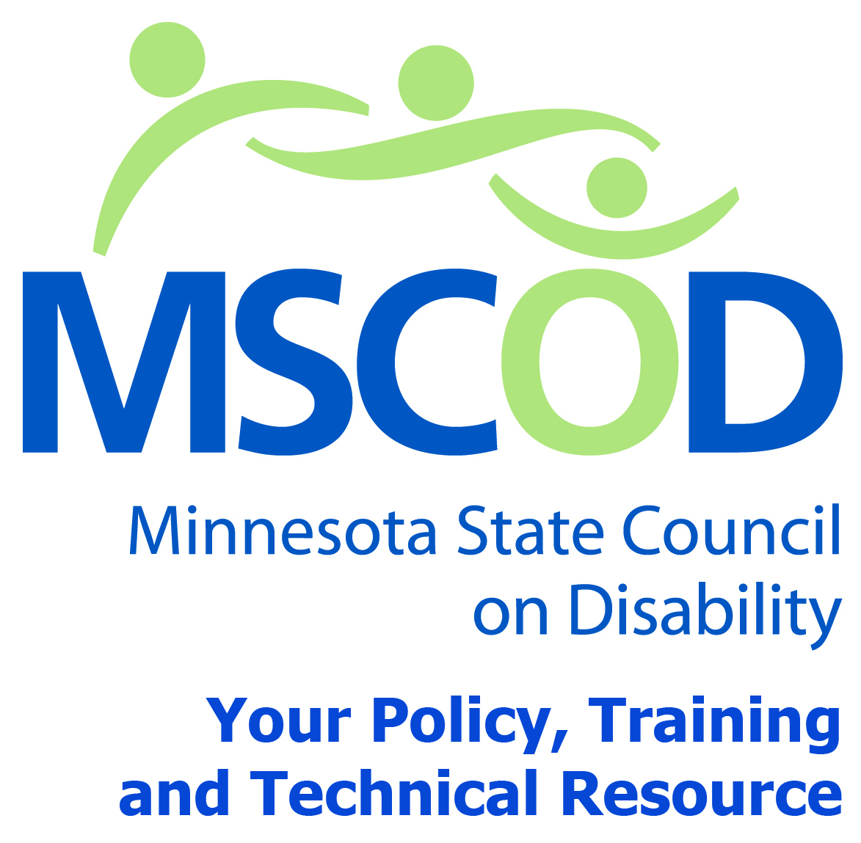

MSCOD Council Meeting Agenda
Thursday, December 4, 2014
Northwest Area Foundation
60 Plato Boulevard East - Suite 400 St. Paul, Minnesota 55107
9:00 a.m.-2:45 p.m.
9:00 a.m.: Subcommittee Meetings (105 min).
10:45 a.m.: BREAK (10 min)
10:50 a.m.: Call to order and Introductions (5 min).
ACTION: Approval of Agenda and ACTION: Approval of Minutes
11:00 a.m.: Legislative Presentations (60 min).
MOVEMN – Dave Vanholten, TLC
MACIL –Vicki Dalle-Molle.
Equipalife - Carol Fury, Executive Director
MSCOD, David Fenley – Accommodation Study
MSCOD, Margot Imdieke Cross - Disability Parking
12:00p.m.: RECESS (45 min).
12:45p.m.: Call to order and Introductions (5 min).
12:50 p.m.: Speaker- Rebecca Covington, Executive Director MN CCD (30 min).
MA Reform
MA Income Standards
MA-EPD
1:20 p.m.: Sub-committee updates (25 min).
Accessibility
Employment
Events
ADA 25th anniversary event update
1:45 p.m.: ELECTIONS (15 min).
2:00 p.m.: BREAK (10 min).
2:10 p.m.: Public comment (5 min).
2:15 p.m.: Chairs report (30 min).
Executive Director’s report
Budget approval
Other
2:45 p.m.: Adjourn
This document is also available in accessible formats.

