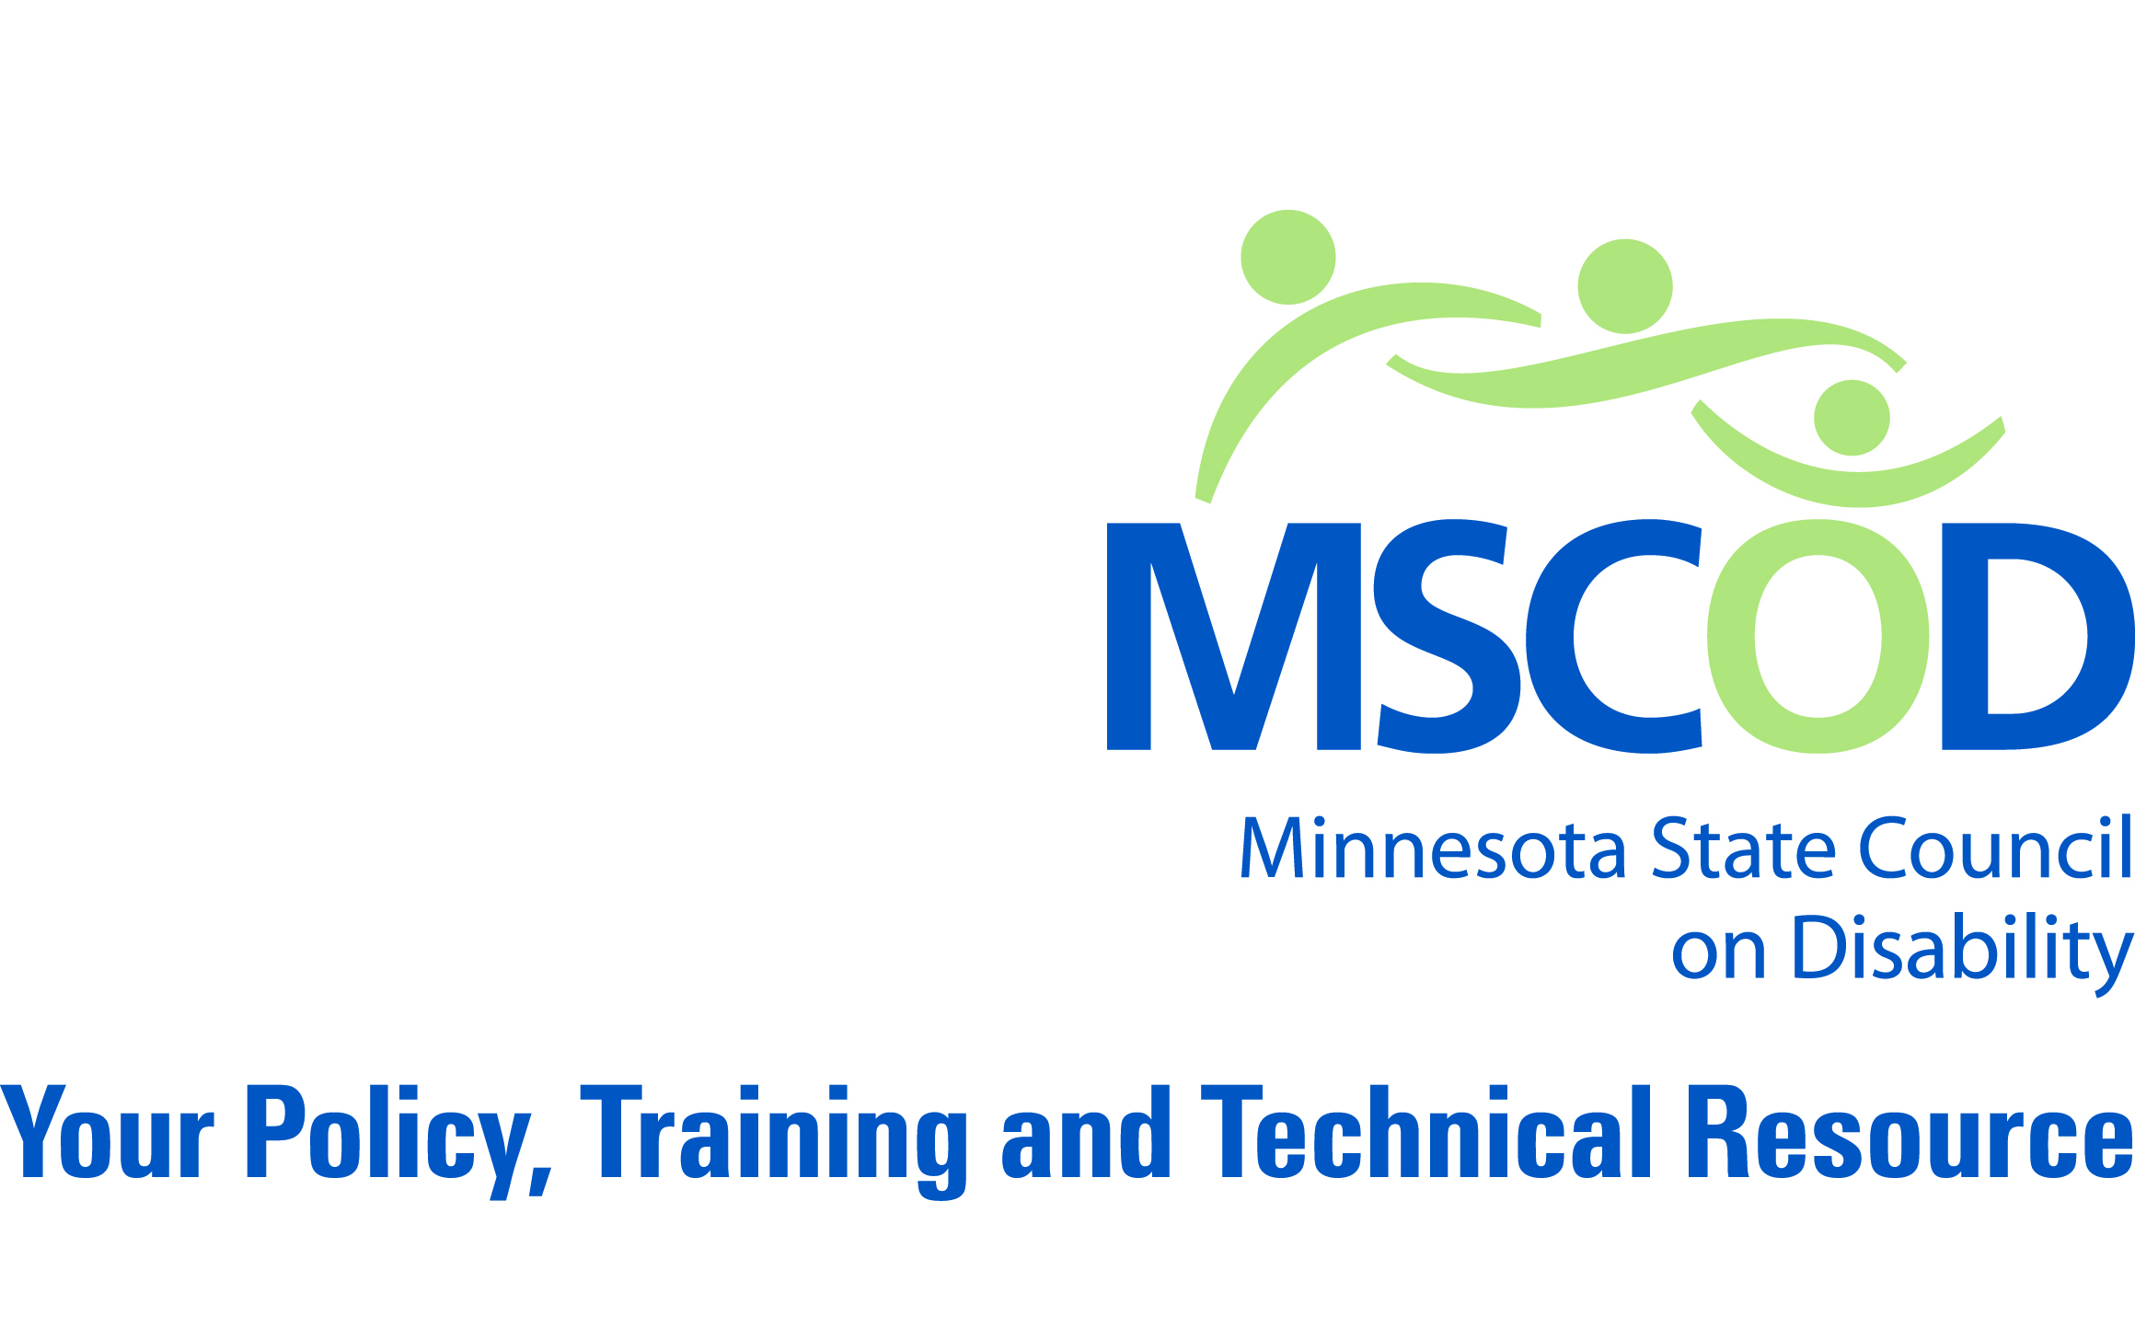
MSCOD SUNSET COMMISSION REPORT

EXECUTIVE SUMMARY:

WHO WE ARE
MSCOD was created to advise the governor, state agencies, state legislature, and the public on disability issues.
People with disabilities represent approximately 20% of Minnesota’s population, and as we age, that number will increase. Individuals with disabilities are living longer, more inclusive and more productive lives than ever before in history. People in general are living longer. We know that as the population ages, in particular, as the baby boomers age, people will acquire age-related disabilities.
MSCOD was established in 1973 in the midst of the disability civil rights movement which brought forth the first piece of federal disability-specific civil rights legislation in our nation’s history. MSCOD’s charge was broad in that our original issues, sparked by the sentiment of the time, dealt with: high unemployment rate of people with disabilities, lack of adequate accessible transportation, inclusion in education. MSCOD also was charged with regaining dignity and well-being of the de-institutionalizing of the state’s most vulnerable population out of expensive and in some cases, abusive institutional settings. The voice of people with disabilities, parents of individuals with disabilities and service providers were heard and together successfully worked with legislators to create an independent state agency. MSCOD is an agency accountable to a council of citizens appointed by the Governor. MSCOD advises government entities and private interest on the requirements of state and federal disability laws and access regulations. Further, we work closely with government and the public to make compliance issues understandable and achievable.
Despite the progress that has been made, we continue to live in a Minnesota that has barriers for people with disabilities. People with disabilities continue to experience disparity with lack of adequate accessible transportation, housing, as well as physical and programmatic access to public and private facilities. People with disabilities experience disproportionate unemployment and underemployment. Because barriers still exist, the Minnesota State Council on Disability’s work is not done. MSCOD’s work is critical to advance Minnesota toward removing barriers for people with disabilities.
MSCOD’s independence as a state agency is critical if Minnesota is to remain accountable to Minnesotans with disabilities. The disability community, under MSCOD’s leadership, must be able to move with agility and focus so that we are able to address and resolve issues at all levels of state government and the private sector. MSCOD must be agile and available to work on statewide public policy decisions as the legislature convenes. We must act strongly and decisively when we advise the Governor and the legislature on disability matters. We must collaborate and build relationships with all state agencies; and are ready to assist all commissioners, directors and decisions makers on matters of inclusion. We meet annually with all new legislators, numerous commissioners and other state executive directors to discuss disability issues. We advise the staff of many state agencies; by sitting on task forces, commissions and work groups. Indeed, MSCOD was created to work with all levels of state government. Today, we are Minnesota’s premiere agency for disability-related technical support. Many organizations rely on our expertise to solve complex disability issues.
After years of advocacy and education within state agencies, we believe that blending MSCOD into a bigger state agency would potentially compromise our ability to look objectively as issues such as access, program compliance, and inclusion.
MSCOD is an integral part of the disability community and State government. We blend the necessary elements of government, private sector interests, the disability community, and the general public to make the greatest impact on public policy.

CORE FUNCTIONS
MSCOD, created with a broad charge, advocates for policies and programs in the public and private sectors that advance the rights of Minnesotans with disabilities from childhood to adulthood. Public policy issue areas include: early identification, physical and programmatic access, education, employment, healthcare, housing, transportation, civil rights, Americans with Disabilities Act (ADA) compliance, and emergency preparedness.
MSCOD’s current staffing compliment is 5.9 FTEs. Our current biennial appropriation is $1,048,000, $524,000 annually. MSCOD is governed by a 15 member citizen council, appointed by the Governor. Council members are appointed from the various economic development regions throughout Minnesota. Currently the council has 3 open seats, 11 members appointed by Governor Pawlenty, and 1 council member appointed by Governor Dayton. Each council member has a disability, has a family member with a disability, or works with people with disabilities.
We have 4 distinct audiences, the governor, the state legislature, state agencies and the general public, including businesses.
We accomplish our mission with 3 primary functional areas:

Policy:
MSCOD advises the governor, state legislature, state agencies and local units of government on issues affecting Minnesotans with disabilities. We analyze legislative initiatives and work with policy makers to ensure they understand the impacts of decisions on Minnesotans with disabilities.
We bring citizens and policy makers together so that people with disabilities have an opportunity to interact with the elected officials. By coordinating statewide events with other disability organizations, policy makers are able to efficiently meet with many constituents. MSCOD’s Annual Legislative Forum (1 per year), Town Hall Meetings (up to 3 per year) and statewide policy dialogues are all broadcast statewide via video conference and web streaming so constituents are able to easily participate without transportation, economic or access barriers. Hundreds of individuals participate each year in these events. We also partner with statewide disability community groups for an annual Disability Day at the Capitol.
MSCOD sits on the executive committee of the Minnesota Consortium for Citizens with Disabilities, a collaboration of over 50 disability organizations working together contributing to public policy decisions that remove barriers for Minnesotans with disabilities.
Additionally, MSCOD has served, and continues to serve in leadership positions on hundreds of state and community committees and commissions since its inception.

Performance measures for Policy work:
MSCOD regularly surveys entities that look to us for policy assistance. We address issues brought to our attention through our annual customer satisfaction survey as well as spot surveys conducted on an ongoing basis. Because we are an agile and independent agency, we are able to focus on emerging issues as they arise. Our customer service satisfaction rate has consistently been rated over 97% over the last several years.

Training:
MSCOD provides training to State of Minnesota employees and managers, business leaders and the general public on a variety of subjects listed below.
- Disability awareness
- Emergency preparedness
- Building codes and building accessibility
- Accessible housing
- Disability parking
- Transportation access
- Employment rights

Performance measures for Training work:
Each training delivered by MSCOD is surveyed for content and delivery. Trainings consistently receive outstanding feedback from clients.

Technical Advice:
MSCOD has been championing access issues since the late 70s, long before ADA. As the first state agency to develop a disability-related information and referral service, MSCOD provides disability related technical assistance to its 4 audiences: the governor, legislature, state agencies and the general public.

Advising State Agencies and the Private Sector:
Early on, MSCOD realized that state agencies needed assistance in understanding and complying with complex disability laws. Over the past three and a half decades, MSCOD developed a unique and important role in state government. MSCOD works with all other state agencies, as needed, to monitor and advise on disability civil rights, the ADA, building code and access compliance. In many instances we have addressed and resolved concerns proactively, avoiding costly legal remedies for the State.
One of MSCOD’s strength has always been, and continues to be, keeping Minnesota’s public and private entities in compliance with building code and access requirements; be they commercial, residential, transportation, public right of way, or recreational. Our public and private partners indicate to us we are the only organization in Minnesota that provides comprehensive guidance on the various state and federal accessibility requirements and the complex relationship between the code requirements and the civil rights obligations in Title II & III of the ADA.

Core areas of technical expertise:
- Understanding of; and compliance issues with the ADA
- Building Code
- Disability parking
- Disability awareness
- Voting accessibility
- Emergency preparedness
- Other laws and regulations

Summary of MSCOD contacts:
Table 1: MSCOD Contacts by Fiscal Year
FY | CONTACTS
2005 | 15,925
2006 | 10,832
2007 | 16,628
2008 | 11,505
2009 | 12,712
2010 | 18,008
2011 | 16,420
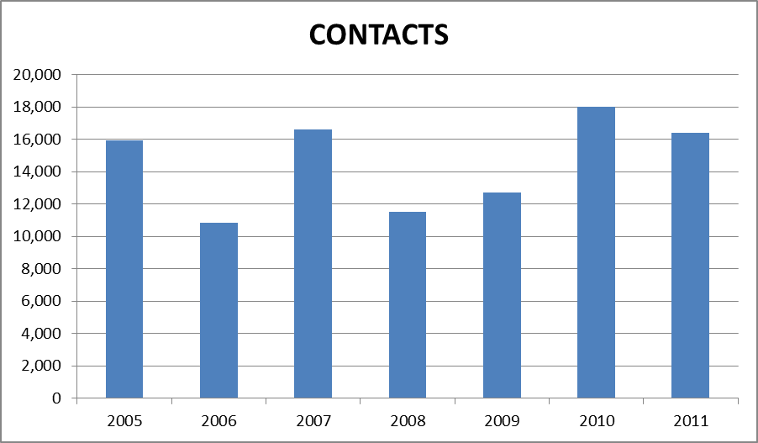
Figure 1: MSCOD Contacts by Fiscal Year
We know we meet our customers’ expectations based on our annual customer satisfaction survey where we have scored over 97% satisfaction for the past 7 years.

