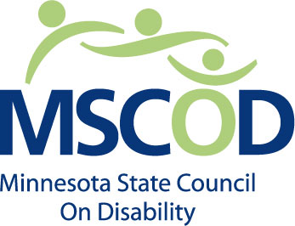

FOR IMMEDIATE RELEASE
February 28, 2014
CONTACT: Shannon Hartwig
651-361-7800

MEDIA ADVISORY
MINNESOTA STATE COUNCIL ON DISABILITY TO ADDRESS NEED TO CLEAR SIDEWALKS OF SNOW AND ICE DURING PRESS CONFERENCE
The Minnesota State Council on Disability, a state agency that advises the governor, legislature, state agencies, and the public on disability policy, will hold a press conference on Friday, March 7th, 2014 at 11 a.m. in room 181 of the State Office Building in St. Paul. Minnesotans with disabilities will share their stories about the difficulty of navigating sidewalks, curb cuts, and transit stops that have not been cleared. Information will also be given on how to report a sidewalk that needs to be cleared.
WHAT: Press conference on important of clearing sidewalks for Minnesotans with disabilities.
WHO: Hosted by the Minnesota State Council on Disability.
WHEN: Friday, March 7th, 2014; 11:00 a.m.
WHERE: State Office Building, room 181
St. Paul, MN 55155
HOW: For more information, contact the Minnesota State Council on disability at 651-361-7800.
###

