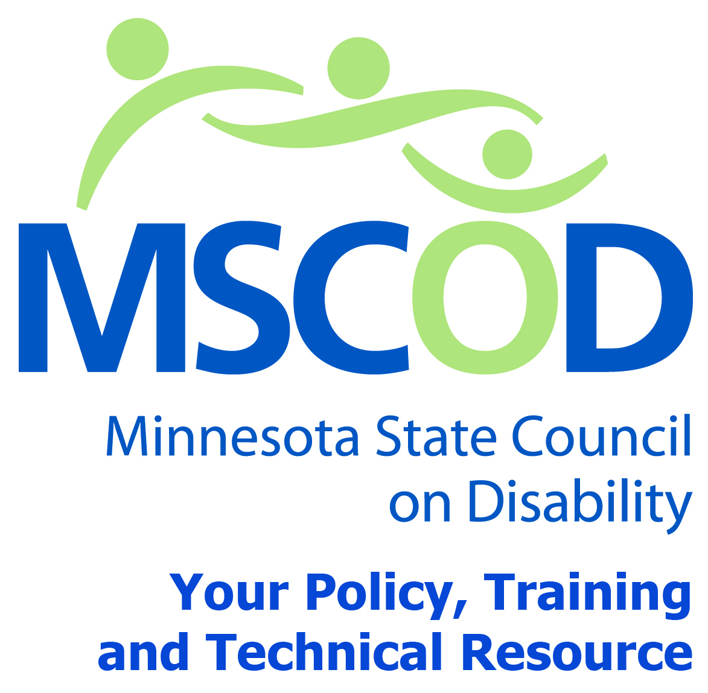

MSCOD Council Meeting Agenda, Tuesday, March 24, 2015
Individual Legislative Visits
9:00 a.m. – 1:00 p.m.
Noon - LUNCH ON YOUR OWN! (See Lunch Location Lists)
Meeting
12:00 p.m.-3:30 p.m.
SOB Room 400S
100 Rev Dr. Martin Luther King Jr Boulevard. St. Paul, MN 55155
9:00 a.m.: Individual Meetings with Legislators, meeting times will vary. You will be contacted by MSCOD Staff with your individual appointment information.
12:00 p.m.: Lunch –ON YOUR OWN No Food allowed in the meeting room.
1:00 p.m.: Call to order and Introductions (5min).
ACTION: Approval of Agenda and ACTION: Approval of Minutes
1:05 p.m.: Budget and Financial Reporting Process (45min)
SMaRT – Tracy Sigstad
1:55 p.m.: ADA updates (15 min).
Andrew Mosca, MSCOD
2:10 p.m.: Legislative updates (25 min).
David Fenley , MSCOD
2: 35 p.m.: Chair’s report (10min).
2: 45 p.m.: Executive Director’s report (5min).
ACTION: Approval of Executive Committee motions.
2:50 p.m.: Other Business (5min).
2:55 p.m.: Public Comment (5min).
3:00 p.m.: Adjourn
This document is also available in accessible formats.

