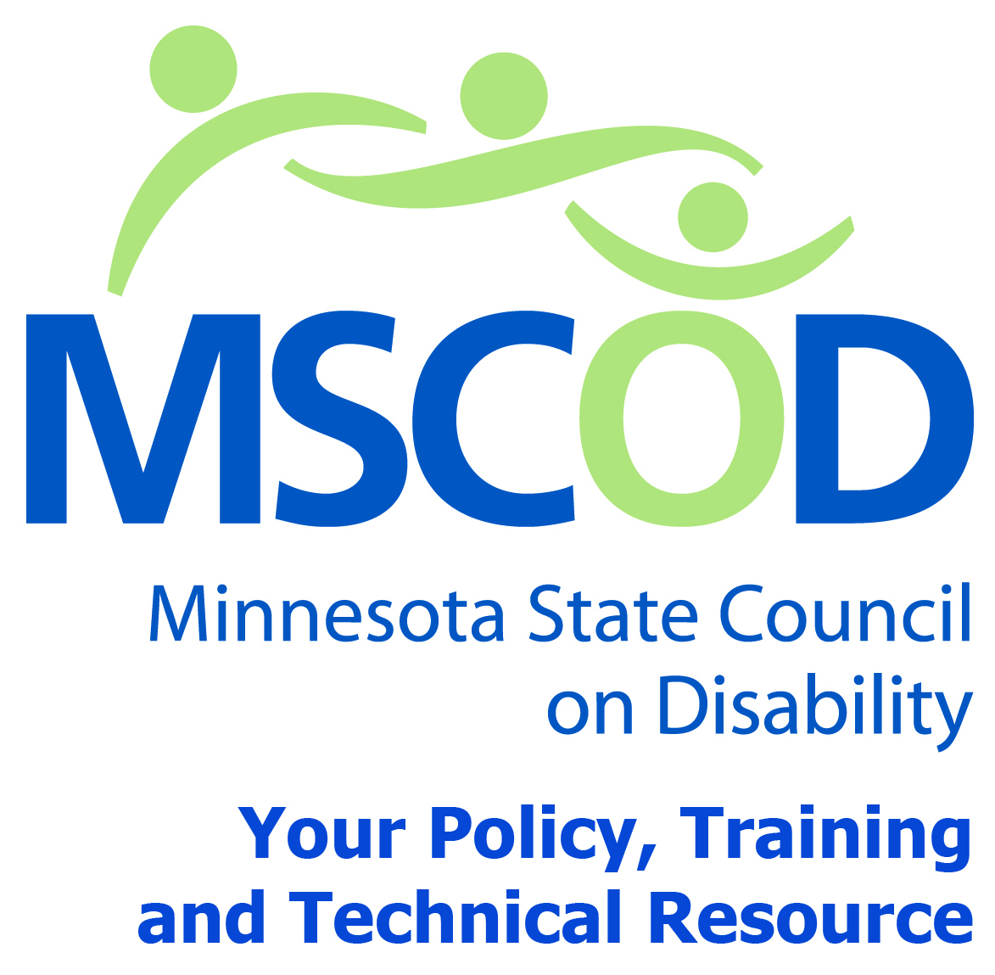

MSCOD Council Meeting Agenda
Thursday, June 4, 2015
121 East 7th Place Saint Paul, MN 55101
Main Line phone code: Please call 1-888-742-5095 and enter 2854189640
9:00 a.m.-3:30 p.m. Metro Square-Lower Level Room 2
9:00 a.m.: Call to order and Introductions (5 min).
ACTION: Approval of Agenda and ACTION: Approval of Minutes
9:05 a.m.: WIOA presentation - Kim Peck, Director of Vocational Rehabilitation Services - Discussion (55 min).
10:00 a.m.: Proposed Regional Transportation Council presentation - Noel Shughart, MNDOT-MSCOD council input (30 min).
10:30 a.m.: BREAK (15 min).
10:45 a.m.: Olmstead update and community engagement plan review/discussion
Kristin Jorenby, OIO(45 min).
11:30 a.m.: RECESS (40 min).
12:10 p.m.: Call to order and Introductions (5 min).
12:15 p.m.: ADA Symposium, Atlanta – Shannon, Stuart and Margot (15 min).
12:30 p.m.: Legislative update – David Fenley (30 min).
1:00 p.m.: BREAK (10 min).
1:10 p.m.: Sub-committee updates (50 min).
Access
Employment
ADA 25th anniversary event update
2015 MN State Fair
2:00 p.m.: Public comment (5 min).
2:05 p.m.: Chairs report (15 min).
2:20 p.m.: Executive Director’s report (15 min).
2:35 p.m.: Other (10 min).
2:45 p.m.: Adjourn
This document is also available in accessible formats.

