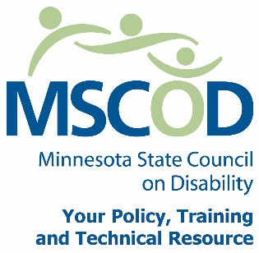

Notice of Appointments by Governor Dayton
July 9, 2015
FOR RELEASE FOR RELEASE FOR RELEASE FOR RELEASE FOR RELEASE FOR RELEASE FOR RELEASE
ST. PAUL, MN –Governor Mark Dayton announced the following appointments to the Council on Disability.
The Minnesota State Council on Disability (MSCOD) is a state agency providing leadership to empower and strengthen the rights of Minnesotans with disabilities.
We collaborate with the public and private sectors as a policy and technical resource advisor.

James Thalhuber – Blaine, MN
Council on Disability
Chair
Effective: June 30, 2015
Term Expires: January 1, 2018

Timothy Boyer – Bemidji, MN
Council on Disability
Member
Effective: June 30, 2015
Term Expires: January 1, 2018
Reappointment

Nancy Fitzsimons – North Mankato, MN
Council on Disability
Member
Effective: June 30, 2015
Term Expires: January 1, 2018
Reappointment
For more information contact the Minnesota State Council on Disability. We are a state agency providing leadership to empower and strengthen the rights of Minnesotans with disabilities. We collaborate with the public and private sectors as a policy and technical resource advisor.
Please contact MSCOD at 651.361.7800 (V/TTY) or council.disability@state.mn.us with questions.
For more information contact the Minnesota State Council on Disability. Phone: 651.361.7800 or 1.800.945.8913V/TTY. Email: council.disability@state.mn.us
###

