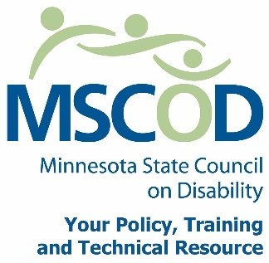

MSCOD Council Meeting Agenda
REVISED - 9/14/2015

Thursday, September 24, 2014
Northwest Area Foundation
60 Plato Boulevard East - Suite 400 St. Paul, Minnesota 55107
9:00 a.m. - 3:30 p.m.
9:00 a.m.: SWOT Analysis, Kris Van Amber (END at 12:50 p.m.).
10:30 a.m.: BREAK (15 min)
10:45 a.m.: SWOT Analysis (continued).
12:00 p.m.: Working Lunch
1:00 p.m.: Call to order and Introductions (5 min).
ACTION: Approval of Agenda and ACTION: Approval of Minutes
1:05 p.m.: Chairs report (15 min).
Executive Director’s report (15 min).
1:35 p.m.: Legislative Updates (5 min).
1:40 p.m.: Committees (30 min).
Committee Model
Updates: Access
Employment
Events
ADA 25th anniversary event update
2:10 p.m.: Public comment (5 min).
2:15 p.m.: BREAK (15 min)
2:30 p.m.: TPT documentary (30 min).
3:00 p.m.: Meeting Recap (30 min).
Other Business
3:30 p.m.: Adjourn
This document is also available in accessible formats.

