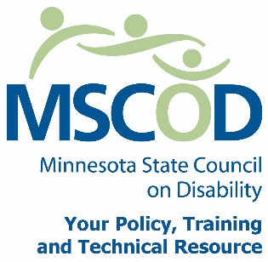
November 18, 2015
FOR RELEASE ∙ FOR RELEASE ∙ FOR RELEASE ∙ FOR RELEASE ∙ FOR RELEASE ∙ FOR RELEASE ∙ FOR RELEASE

Protect Your Business – Remove Access Barriers Now!

Don’t Wait to be Sued!
Businesses throughout Minnesota have been impacted by the actions of an attorney and a group of individuals with disabilities who claim they want access barriers removed. Both the Americans with Disabilities Act (ADA) and the Minnesota Human Rights Act contain language requiring businesses to remove barriers that prevent or impede access to the business. In the ADA, the requirement to remove barriers has been in place for over two decades and is framed within what is readily achievable, easily accomplishable, and able to be carried out without much difficulty or expense.
Businesses are required to identify barriers, prioritize the barriers, and put a plan in place to remove the barriers as quickly as they can afford to do so. Unfortunately, countless businesses have either not been aware of, or ignored this requirement and have failed to put in such access features as code compliant disability parking, ramping a step or two, or installing grab-bars in restrooms. This failure to comply has left the door wide open for lawyers and frustrated individuals with disabilities to sue the businesses.
With over 120 current court cases filed and a significant number of out of court settlements, businesses are feeling the sharp sting of paying out attorney’s fees before focusing on the issue at hand, barrier removal. Business owners have reported that the typical pay-out for attorney’s fees have been ranging between $5,000 and $8,000 per settlement. Barrier removal should be the main goal of these suits, but it has been reported that this is not the case. Even if barriers are removed lawsuits have proceeded. There have been reports of instances of suits being settled for lawyer’s fees without any barrier removal taking place. If this happens a business may still be sued for the very same violation by another lawyer or another person with a disability and the same lawyer that previously settled.

BUSINESSES NEED TO ACT NOW.
The Minnesota State Council on Disability (MSCOD) urges every business open to the public to protect themselves and become more accessible to individuals with disabilities and an aging community. First and foremost, identify access barriers either with our self-survey or contract with an accessibility specialist to conduct an audit. Prioritize the barriers starting in the parking lot and working your way into your business, put a plan in place and start removing the barriers as quickly as possible. These lawsuits are arising just now in Minnesota, but have been a trend in other states. Please take necessary steps to protect your business by increasing access to every Minnesotan, it’s not only the law, it’s good business! For more information on barrier removal please go to www.disability.state.mn.us.
For more information contact the Minnesota State Council on Disability. Phone: 651.361.7800 or 1.800.945.8913V/TTY. Email: council.disability@state.mn.us
###

