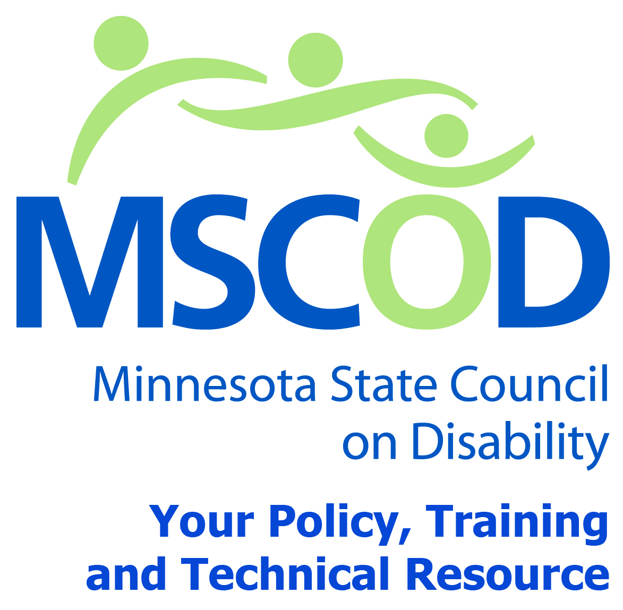

MSCOD Council Meeting Agenda
Wednesday, December 2, 2015
12:00 p.m.-2:00 p.m.
MSCOD
121 East 7th Place Suite 107
St. Paul, MN 55101
Please plan to attend via Conference Line
Main line phone number: 1-888-742-5095
Pass code 2854189640
12:00 p.m.: Call to order and Introductions (5 min).
ACTION: Approval of Agenda and ACTION: Approval of Minutes
12:05 p.m.: Committee Updates (15 min).
Access
Employment
ADA Events October 28th event recap
12:20 p.m.: 2016 Strategic Planning (30 min).
12:50 p.m.: Legislative Updates (45 min).
Public Policy Agenda (handout-working document)
1:35 p.m.: Public comment (5 min).
1:40 p.m.: Chairs report (5min).
Executive Director’s report (10 min).
Other Business (5min).
2:00 p.m.: Adjourn
This document is also available in accessible formats.

