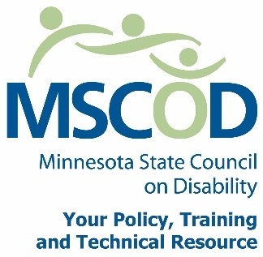

MSCOD Council SPECIAL Meeting Agenda
Tuesday November 17, 2015 3:30 p.m.
MSCOD Office 121 E. 7th Place, Suite 107, St. Paul, MN 55101
3:30 p.m. - 3:45 p.m.
3:30 p.m.: Call to order and Introductions (5 min).
ACTION: Approval of Agenda
3:35 p.m.: Timing of the Executive Committee election (5 min).
ACTION: Move date of Executive Committee election
3:40 p.m.: Executive Committee Nomination Task Force (5 min).
ACTION: Approve Nominating Task Force
3:45 p.m.: Adjourn

Main Line phone code
Please call 1-888-742-5095
and enter 2854189640
This document is also available in accessible formats.

