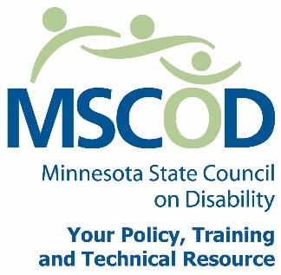

MSCOD Council SPECIAL Meeting Agenda
12/16/2014
Via Conference line
MSCOD Office 121 E. 7th Place, Suite 107, St. Paul, MN 55101

Agenda
1:30 p.m. to 2:30 p.m.
1:30 p.m.: Call to order and Introductions (5 min).
ACTION: Approval of Agenda and ACTION: Approval of Minutes
1:35 p.m.: 2015 MSCOD Legislative Issues (50 min).
2:25 p.m.: Public comment (5 min).
2:30 p.m.: Adjourn
This document is also available in accessible formats.

