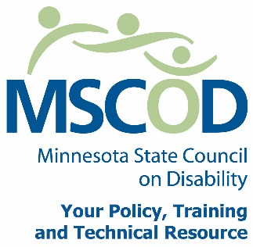

MSCOD Council Meeting Agenda
Thursday, June 2, 2016
10:00 a.m. to 2:30 p.m.
MSCOD
Metro Square Conference Center
Lower Level Room 2
121 East 7th Place
St. Paul, MN 55101
Please plan to attend IN PERSON
10:00 a.m.: Call to order and Introductions (15 min).
ACTION: Approval of Agenda and ACTION: Approval of Minutes
10:15 a.m.: Ice Breaker (15 min).
10:30 a.m.: Committee Updates (20 min).
Access
Employment
10:50 a.m.: Legislative Updates (30 min).
11:20 a.m.: Council Self Evaluation Survey (10 min).
Handouts will be sent electronically prior to the meeting, and printed copies will be available at the meeting for those attending in person.
11:30 a.m.: Disability Parking Survey Results (15 min).
11:45 a.m.: Customer Satisfaction Survey Results (15 min)
12:00 p.m.: MN State Fair updates (10 min).
12:10 p.m.: Break (50 min).
1:00 p.m.: Legacy Updates (10 min).
1:10 p.m.: Nominations Committee for the Executive Committee (5 min).
1:15 p.m.: Budget Update (10 min).
1:25 p.m.: Council Member In Service (15 min).
1:40 p.m.: Break (10 min).
1:50 p.m.: Chairs report (15 min).
Council Member Responsibilities-Discussion
Executive Director’s report (10 min).
Other Business (5min).
2:25 p.m.: Public Comment (5min).
2:30 p.m.: Adjourn
This document is also available in accessible formats.

