Building Access
Short Survey
121 East 7th Place, Suite 107
St. Paul, MN 55101
651-361-7800 or 1-800-945-8913
www.disability.state.mn.us
Some of the information in this document was developed by the Adaptive Environments Center in cooperation with the Massachusetts Executive Office of Administration and Finance Division of Capital Planning and Operations and the Office of Disability Affairs. Based on Code Revisions of 2007, updated in 2015.

STEP BY STEP
- Identify team members. These individuals will provide guidance and assistance during the planning, surveying, and reviewing steps. The team might include the facility manager, chief administrator, maintenance supervisor, 504 Coordinator or Equal Opportunity officer, financial staff, and persons with disabilities.
- Fill in the Survey Form. For each building to be surveyed, read through the entire section and determine the total number of Survey Forms that will be needed. If you have more than one building at your facility, use additional Survey Forms.
- Copy the Survey Forms. Photocopy the necessary survey forms for the facility being reviewed. Keep this survey booklet as a reference and for future surveying needs. Be sure to copy an extra set of forms to have handy when surveying (in the event an unexpected barrier is encountered). Collate and staple the appropriate forms on a building-by-building basis. For each survey form, fill out each and every question. It is very important that all issues are addressed and that an answer is provided. If a particular question is not applicable, then note this by checking “N/A”. This will indicate that the question has not been overlooked or forgotten. The importance of this will become clear when the survey is reviewed at a later date. A comment section is provided at the end of each survey form. Use this area for notes and to clarify special situations which may occur.

SITE
Site accessibility involves arriving at the site, parking a vehicle or being dropped off, and getting to a building or outdoor recreation area. It also includes the ability to move from one building to another when there is more than one building at a facility.
People with mobility issues who arrive by vehicle need to be able to enter buildings on their own – independently – without assistance from others. Direct and safe walkways from these areas as well as from the street and transportation stops are essential for people with mobility and sight impairments.

BUILDING
Once an accessible route has been provided to the building, an accessible entrance is essential to making a building usable by people with disabilities. As many entrances as possible should be accessible, especially the entrance used most often by the nondisabled public. Asking individuals with disabilities to use basement or back doors not used by others not only discriminates against them but also puts them at a disadvantage by depriving them of services provided in a front lobby: signage, reception, and waiting areas. It is important that once someone is inside the entrance that they be able to easily gain direct access to elevators and corridors that lead to other parts of the building.
Sixty percent of primary public entrances to a building are required to be accessible. As many employee and service entrances as possible should also be accessible. For example, in large buildings such as hospitals there may be an emergency entrance, a visitor entrance, and an entrance that staffs use located close to where they park their cars. In this instance, all three entrances should be accessible. It is often the case that parking lots are located at the back of the buildings. If the main entrance is located on a public street but a long walk from the back of the building, both entrances should be made accessible.
Some criteria for determining which entrances should be accessible include:
- It is referred to as the “main entrance” to the building. (If you asked for directions to this building, you would be directed to this entrance.)
- It provides the most direct access to main corridors and elevators (if present) as well as major public function spaces at the entry level such as an auditorium or cafeteria.
- It is an entrance that people use when they enter the building from visitor or staff parking areas.
Accessible routes within and throughout the building or facility are the next area which need to be considered in order to provide access for persons with disabilities. Changes in elevation can be accomplished by ramp, elevator or lift.
People often think that getting around within a building is only a problem for someone using a wheelchair. Individuals with limited or no vision find it difficult to use buildings with poor signage, obstructions in the hallways, and elevators without audible signals. People with leg braces or prosthesis find poorly designed stairs difficult, if not impossible, to use.

SPACES
Once you have made it possible for people to move about the facility easily, you need to determine what spaces should be made accessible. Even if there are only a few people with disabilities currently using a building, there will eventually be more. Remember that individuals with disabilities are not only customers and clients, but they are also employees and management personnel.
Rooms like toilet rooms will be found in all buildings. Other spaces are more specialized and occur less frequently but should be accessible because of their public use.

SURVEY FORMS

BUILDING ACCESS
BUILDING:
DATE OF SURVEY:
STREET ADDRESS:
CITY/STATE:
BUILDING CONTACT NAME:
BUILDING CONTACT INFORMATION:
SURVEYOR’S NAME:
SURVEYOR’S CONTACT INFORMATION:
SURVEYOR’S POSITION OR TITLE:

SITES

PARKING SPACE REQUIREMENTS
- For 1 to 25 parking spaces, 1 Accessible Spaces Required, 1 of which must be Van Accessible
- For 26 to 50 parking spaces, 2 Accessible Spaces Required, 1 of which must be Van Accessible
- For 51 to 75 parking spaces, 3 Accessible Spaces Required, 1 of which must be Van Accessible
- For 76 to 100 parking spaces, 4 Accessible Spaces Required, 1 of which must be Van Accessible
- For 101 to 150 parking spaces, 5 Accessible Spaces Required, 1 of which must be Van Accessible
- For 151 to 200 parking spaces, 6 Accessible Spaces Required, 1 of which must be Van Accessible
- For 201 to 300 parking spaces, 7 Accessible Spaces Required, 2 of which must be Van Accessible
- For 301 to 400 parking spaces, 8 Accessible Spaces Required, 2 of which must be Van Accessible
- For 401 to 500 parking spaces, 9 Accessible Spaces Required, 2 of which must be Van Accessible
- For 501 to 1000 parking spaces, 2% of Total Accessible Spaces Required, of which 1 in every 6, or fraction thereof, must be Van Accessible
- For 1000+ parking spaces, 20 plus 1 for each additional 100 Accessible Spaces Required, of which 1 of 6, or fraction thereof, must be Van Accessible
*NOTE: “van accessible” spaces are included in the number of “accessible spaces required.”
One in every six accessible spaces must be van accessible, having a minimum vertical clearance of 98 inches.

PARKING SURVEY FORM
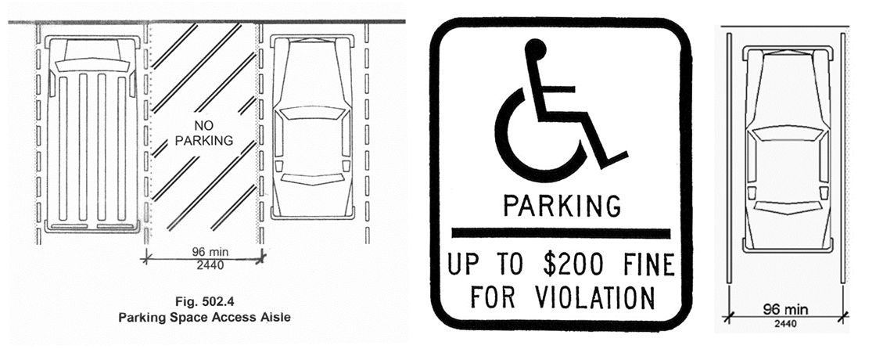
- Are there accessible spaces provided per Parking Spaces Requirements? Yes No N/A
- Are parking spaces 8 feet wide with an adjacent 8 foot wide access aisle? (Parking spaces can share an access aisle.) Yes No N/A
- Are access aisles identified with a sign stating “no parking” centered at the head end of the space no more than 8 feet from the space? Yes No N/A
OR
Only where the sign would obstruct the pedestrian route, is the access aisle marked with “no parking” on the surface of the access aisle? Yes No N/A
- Where the access aisle is marked with a sign, is the bottom edge of the sign between 60 inches and 66 inches above the surface of the access aisle? Yes No N/A
- Does the van accessible space have a minimum clear height of 98 inches at the space and along the vehicular route leading to the space? Yes No N/A
- If all spaces do not have a clear height of 98 inches, do the van spaces have a sign indicating “van accessible”?
Yes No N/A
- Are the access aisles connected directly to the accessible route leading to the building entrance?
Yes No N/A
- Are curb ramps provided along the accessible route where necessary? (e.g., connecting the access aisle to sidewalk) Yes No N/A
- Is each accessible space identified with a sign displaying the international wheelchair symbol, indicate that a permit is required, and that there is a maximum $200 fine for violation? Yes No N/A
- Is the lettering and international wheelchair symbol on the sign white with a blue background?
Yes No N/A
- Is the sign centered at the head end of the space no more than 8 feet from the space? Yes No N/A
OR
If parallel parking, is the sign located on the side of the space at the head end? Yes No N/A
- Is the bottom edge of the sign between 60 inches and 66 inches above the surface of the parking lot?
Yes No N/A
- Are the designated spaces located as close as possible to an accessible entrance? Yes No N/A
- For facilities with more than one accessible entrance, are the designated parking spaces dispersed among the various accessible entrances? Yes No N/A
- Is the parking area and access aisle a firm, stable, slip-resistant surface with a slope of no more than 1:48 (2%) in all directions? Yes No N/A

DROP-OFF ZONE
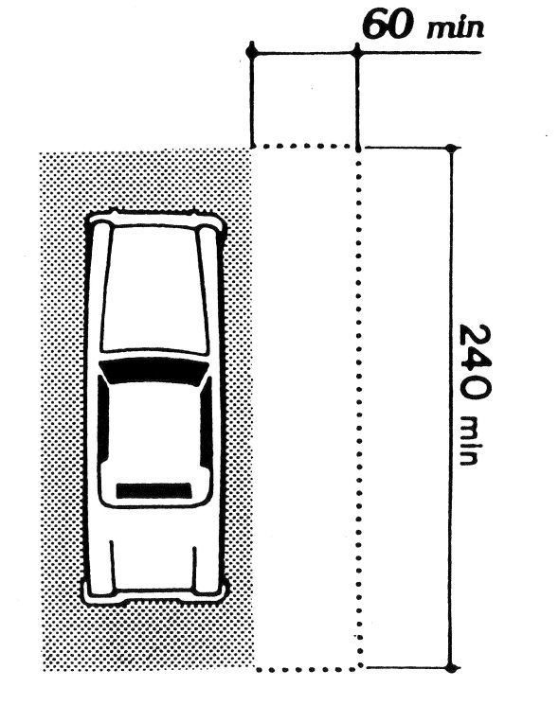
- Does the drop-off area provide an access aisle 5 feet wide by 20 feet long adjacent and parallel to the vehicle pull-up space? Yes No N/A
- Does the drop-off area provide a minimum clear height of at least 114 inches at the space and along the vehicular route leading to the space? Yes No N/A
- Is the parking area and access aisle a firm, stable, slip-resistant surface with a slope of no more than 1:48 (2%) in all directions? Yes No N/A
- Is the access aisle connected directly to the accessible route leading to the building entrance? Yes No N/A
- Are curb ramps provided along the accessible route where necessary (i.e. along the accessible route from parking, drop-off, or sidewalk)? Yes No N/A
- Is the drop-off area located as close as possible to an accessible entrance? Yes No N/A

WALKWAYS
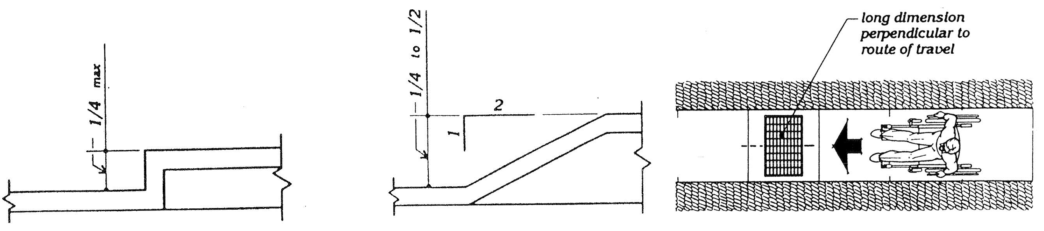
(This section only applies to exterior walkways connecting accessible parking spaces and accessible drop-off areas to accessible building entrances and to exterior walkways connecting buildings that are on the same site.)

- Is the walkway at least 4 feet wide? Yes No N/A
- Is the walkway sloped a maximum of 1:20 (5%) in the direction of travel? Yes No N/A
- Is the cross slope a maximum of 1:48 (2%)? Yes No N/A
- Does the walkway have a firm, stable, slip-resistant surface? Yes No N/A
- Do all changes in level between ¼ inch and ½ inch have beveled edges (Changes greater than ½ inch are not allowed.) Yes No N/A
- If gratings are located within the walkway, do they have spaces no greater than ½ inch wide with the long dimension perpendicular to the direction of travel? Yes No N/A
- Are curb ramps provided along the accessible route where necessary (i.e. along the accessible route from parking, drop-off, or sidewalk)? Yes No N/A

CURB RAMP
- Is the slope of the curb ramp a maximum of 1:12 (8.3%) measured in the direction of travel? Yes No N/A
- Is the curb ramp a minimum of 36 inches wide, exclusive of the flared edges? Yes No N/A
- Is the transition from the curb ramp to the adjoining surface flush and free of abrupt changes?
Yes No N/A
- Is the slope of the surface immediately adjoining the curb ramp a maximum of 1:20 (5%)? Yes No N/A
- Is there a landing at the top of the curb ramp at least 3 feet measured in the direction of travel?
Yes No N/A

RAMP
- Is the ramp a minimum of 36 inches wide (measured between handrails)? Yes No N/A
- Is the maximum slope no greater than 1:12 (8.3%)? Yes No N/A
- Is the cross slope no greater than 1:48 (2%)? Yes No N/A
- Is the surface of the ramp firm, stable, and slip-resistant? Yes No N/A
- Is there a 5-foot landing, measured in the direction of the ramp, at the top and bottom of the ramp?
Yes No N/A
- If the total rise exceeds 30 inches, is there a 5 foot intermediate landing located no more than 30 inches above the bottom of the ramp? Yes No N/A
- If the ramp changes direction at the landing, is a turning space provided on the landing (generally a 5 foot diameter circle)? Yes No N/A
- If the total rise exceeds 6 inches, are there handrails provided on both sides of the ramp? Yes No N/A

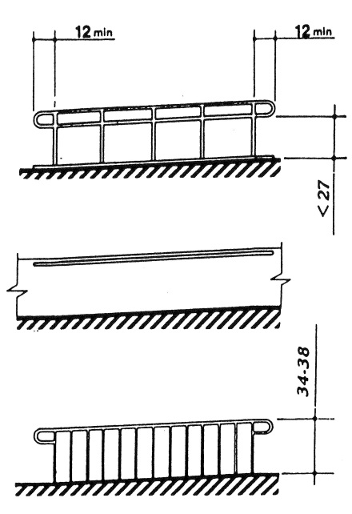
- Are the handrails mounted between 34 inches and 38 inches above the ramp surface? Yes No N/A
- Do handrails extend horizontally 12 inches beyond the top and bottom of the ramp? Yes No N/A
- Is the space between the handrail and the wall a minimum of 1 ½ inches? Yes No N/A
- Are the ends of handrails looped or returned to wall, floor, or post? Yes No N/A
- Do ramps and landings with drop-offs have curbs, walls, or railing which prevent a wheelchair from going over the edge? (Curbs must be at least 4 inches high.) Yes No N/A

DOORWAY
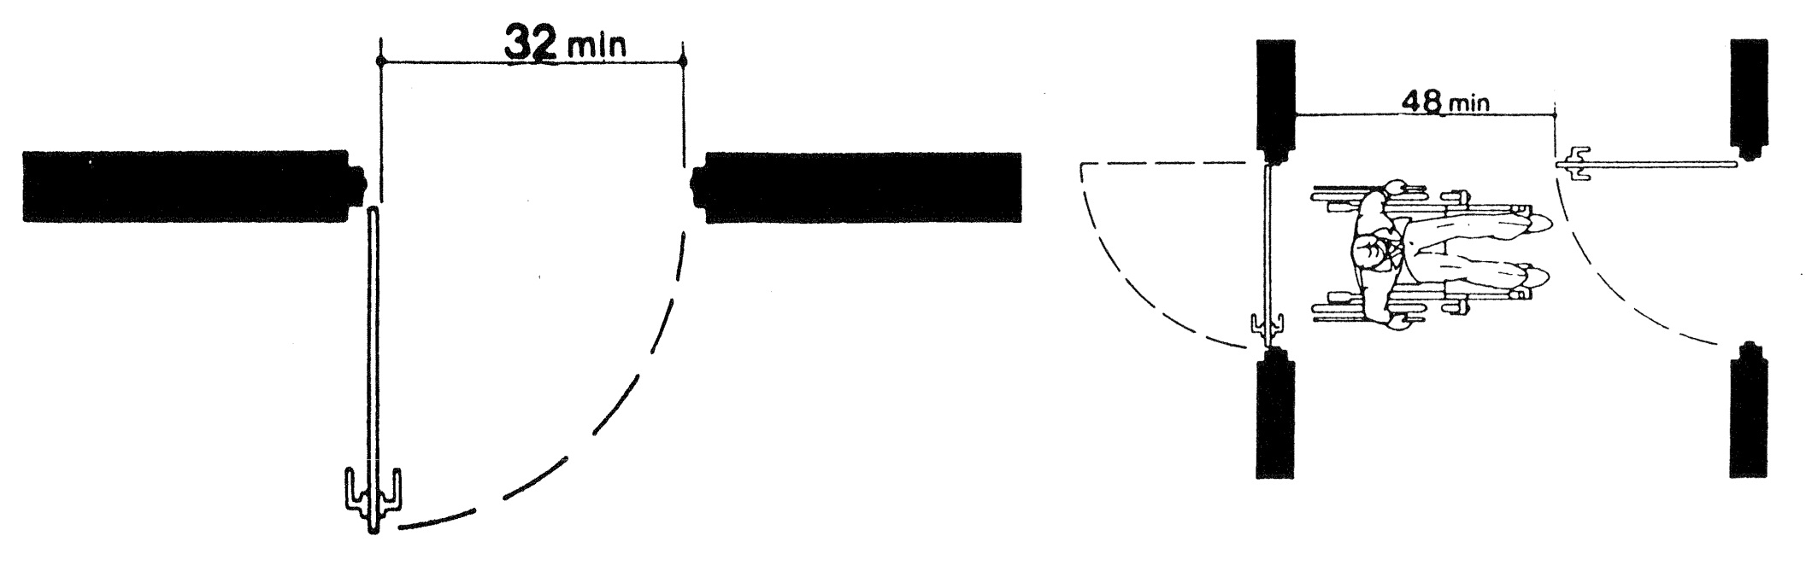

- With the door in a 90 degree open position, is there a minimum of 32 inches of clear space from the face of the door to the latch side doorstop? (Exception: doors not requiring passage, such as shallow closets, may have clear openings of 20 inches minimum.) Yes No N/A
- If a doorway has two independently operated door leaves, does at least one leaf provide the 32 inch clear space?
Yes No N/A
- If there are two sets of doors in a series, as in a vestibule, is there a minimum distance between the doors of 4 feet plus the width of the in-swinging door? Yes No N/A
- If there are two sets of doors in a series, as in a vestibule, is there a turning space between the doors? (Generally a 5 foot diameter circle.) Yes No N/A
- Is the threshold no more than ½ inch in height? Yes No N/A
- Is the door hardware operable by a single effort with one hand not requiring tight grasping, pinching or twisting of the wrist? (such as a lever or loop style?) Yes No N/A
- Is the threshold no more than ½ inch in height? Yes No N/A
- Is the door hardware mounted no more than 48 inches above the floor? Yes No N/A
- For interior doors, is the force required to open the door no more than 5 lbs.? (Does not apply to “fire” doors.) Yes No N/A
- Is there a minimum of 18 inches of clear space on the latch side from the pull side of the door? (Not required for doors with automatic opener.) Yes No N/A
- If the door has both a closer and a latch, is there a minimum of 12 inches of clear space on the latch side from the push side of the door? (Exceptions: doors with automatic opener.) Yes No N/A

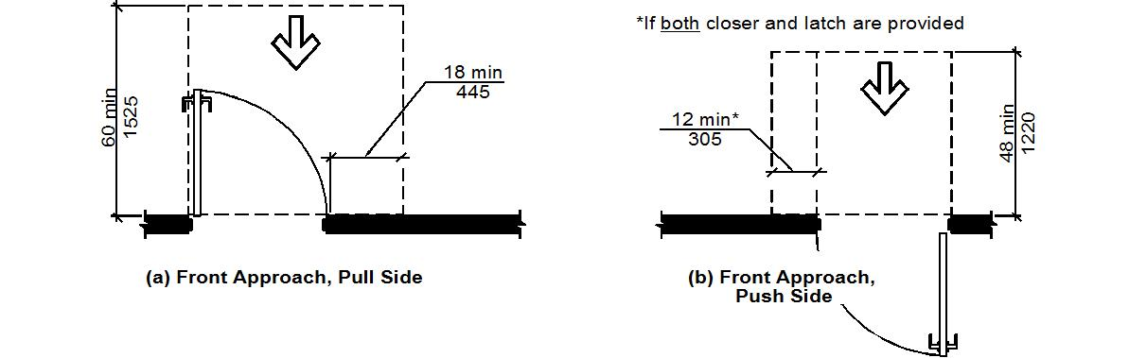
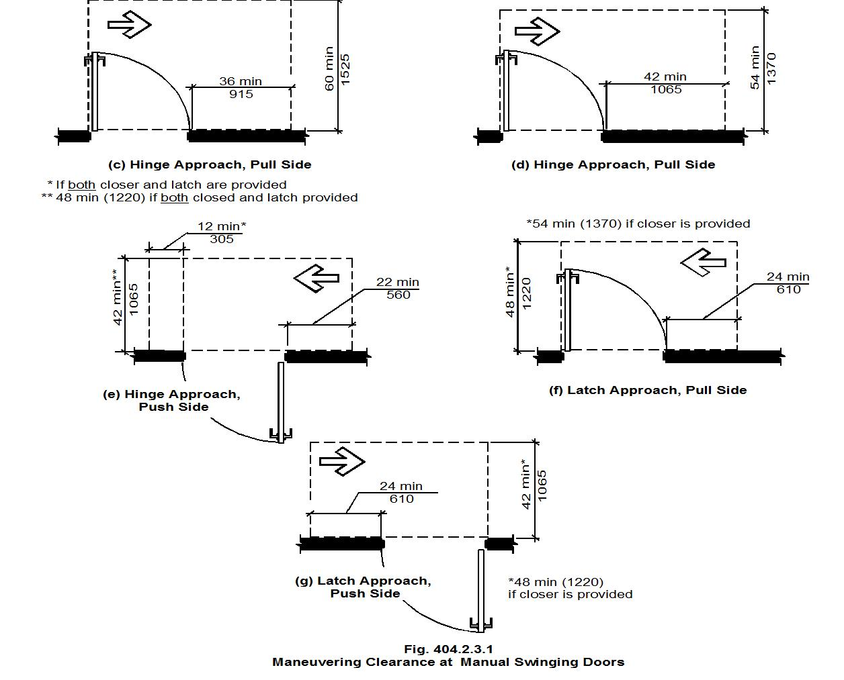

- Do other doors have clearances as required in diagrams above? (not required for doors with automatic opener.) Yes No N/A
- If the door has an automatic push button control, is the push button control mounted no more than 48 inches above the floor? (prefer 30 to 36 inches above the floor) Yes No N/A

CORRIDOR
- Are all corridors a minimum of 36 inches wide? Yes No N/A
- If there are portions of the corridor less than 36 inches wide, are they a minimum of 32 inches wide with a maximum distance of 24 inches? Yes No N/A

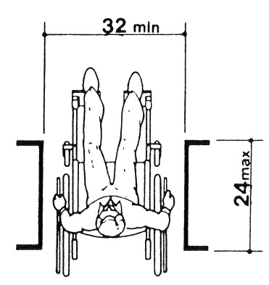
- Do public use counters have a section of the counter that is at least 36 inches wide and no more than 36 inches above the floor? Yes No N/A
- Do objects protruding from walls between 27 inches and 80 inches above the floor project no more than 4 inches from the wall? Yes No N/A

SPACES

TOILET ROOM
(please fill out one assessment sheet for each Toilet Room unless they are identical to each other)
Male Female Unisex Floor or Building

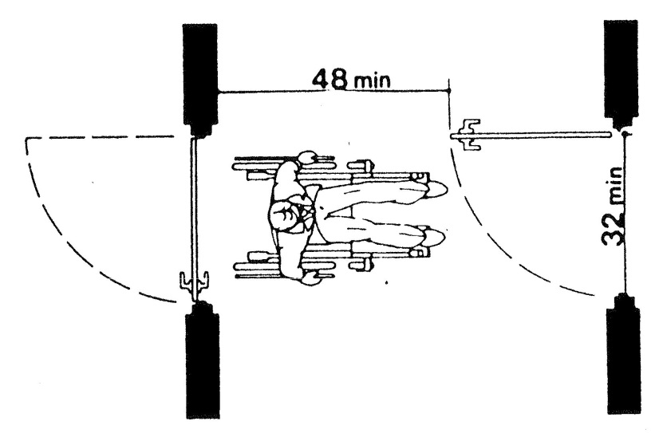
- With entry door in a 90 degree open position, is there a minimum of 32 inches of clear space from the face of the door to the latch side door stop? Yes No N/A
- If there are two sets of doors in a series, as in a vestibule, is there a minimum distance between the doors of 4 feet plus the width of the in-swinging door? Yes No N/A
- If there are two sets of doors in a series, as in a vestibule, is there a turning space between the doors (generally a 5 foot diameter circle)? Yes No N/A
- Is the toilet bowl centered between 16 inches and 18 inches from a side wall? Yes No N/A
- Is the toilet area, measured from the wall next to the toilet, a minimum of 60 inches wide? Yes No N/A

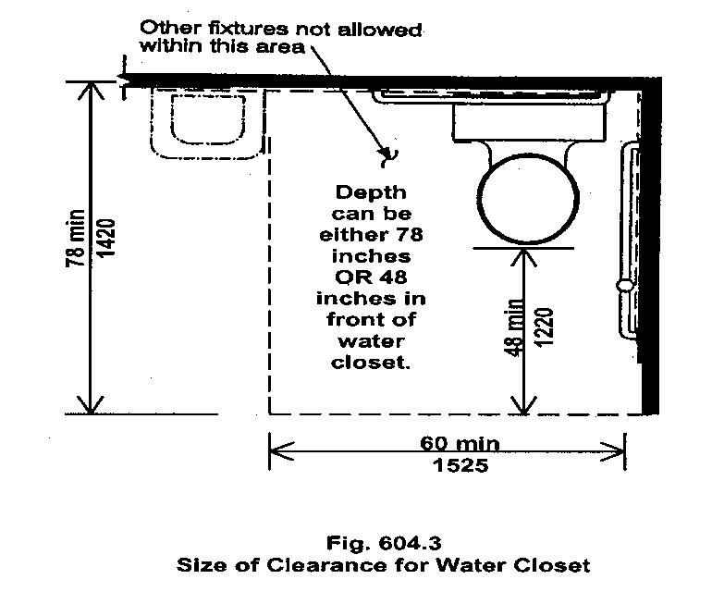
- Does the toilet area have a minimum of 48 inches of clear floor space from the front of the toilet bowl to the compartment/room wall? Yes No N/A
OR
Is the depth of the space at least 78 inches measured from the wall behind the toilet? Yes No N/A
- Is the flush valve located on the wide side of the toilet area mounted no more than 48 inches above the floor? (If mounted above the grab bar, the flush valve must be at least 12 inches above the grab bar but no more than 48 inches above the floor.) Yes No N/A
- Is the height of the toilet seat between 17 inches and 19 inches above the floor? Yes No N/A
- Does the compartment door have a minimum clear opening of 32 inches? Yes No N/A
- Is the compartment or room, door-locking hardware easy to operate without requiring tight grabbing, pinching or twisting? Yes No N/A
- Are both horizontal and vertical grab bars provided as shown in diagrams on the next page? Yes No N/A

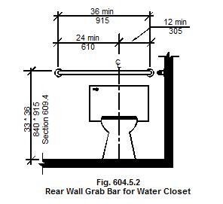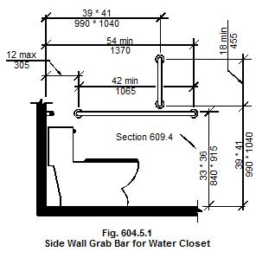
- Is the toilet paper dispenser mounted below the horizontal grab bar as shown in diagram? Yes No N/A

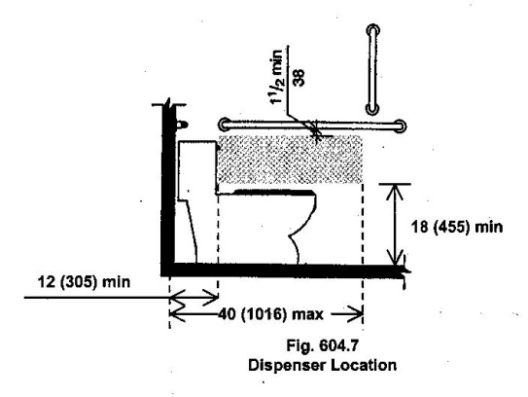
- If there are 2 or more toilet compartments in a room, is there an ambulatory accessible compartment measuring 36 inches wide provided in addition to the wheelchair accessible compartment? Yes No N/A
- If there are two or more urinals, is at least one urinal mounted with the rim no more than 17 inches above the floor? Yes No N/A
- Is the rim of the sink a maximum height of 34 inches above the floor? Yes No N/A

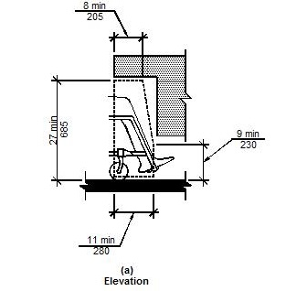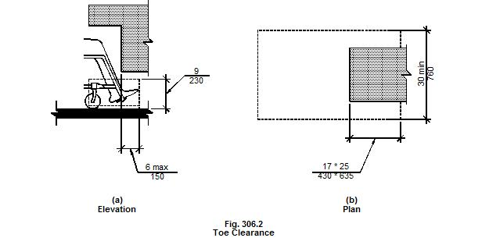

- Is there a minimum of 27 inches of knee clearance from the floor to the bottom of the apron or counter?
Yes No N/A
- Does the knee clearance extend at least 8 inches back from the front edge? Yes No N/A
- Is there a toe clearance that extends at least 17 inches back from the front edge at a height of 9 inches above the floor? Yes No N/A
- Are the knee and toe clearances at least 30 inches in width? Yes No N/A
- Do the faucets have lever handles or are they electronically controlled (operable with one hand and not requiring tight grasping, pinching, or twisting of the wrist)? Self-closing faucets that require both reaching forward and pushing down to activate are not recommended. Yes No N/A
- If a self-closing faucet is in use, does the water flow for a minimum of 10 seconds? Yes No N/A
- Is the plumbing insulated or otherwise covered so that there are no sharp or abrasive edges exposed?
Yes No N/A
- Is there a clear floor space 30 inches wide by 48 inches long in front of the sink for a forward approach?
Yes No N/A
- Is the mirror mounted no higher than 40 inches to the bottom reflective edge? Yes No N/A
- Is there at least one of each type of accessory (soap dispenser, towel dispenser, etc.) mounted such that the operating mechanism is no more than 48 inches above the floor? Yes No N/A
- Does each accessible fixture and accessory have a clear floor space 30 inches wide by 48 inches long in front of or adjacent to the fixture or accessory? Yes No N/A
- Does the toilet room have adequate space to allow a 5 foot diameter circle (to allow a wheelchair to turn 180 degrees)? Yes No N/A
- Diaper changing tables are not allowed in the wheelchair accessible toilet compartment. Yes No NA

DRESSING AND FITTING ROOM
- Is there adequate clear floor space provided within the room to allow a person using a wheelchair to make a 180-degree turn (generally a 5-foot diameter circle)? Yes No N/A
- With the entry door in a 90-degree open position, is there a minimum of 32 inches of clear space from the face of the door to the latch side door stop? Yes No N/A
- Is the door hardware operable by a single effort with one hand not requiring tight grasping, pinching, or twisting of the wrist? Yes No N/A
- Does the room provide a fixed bench 17 inches to 19 inches above the floor that is between 20 inches to 24 inches deep and 42 inches minimum in length? Yes No N/A
- Does the bench have a back rest (a wall can serve as a back rest)? Yes No N/A
- Do 5% - but not less than one – of the dressing rooms for each type of use in each cluster of dressing rooms comply with the requirements in this section? Yes No N/A

DRINKING FOUNTAIN
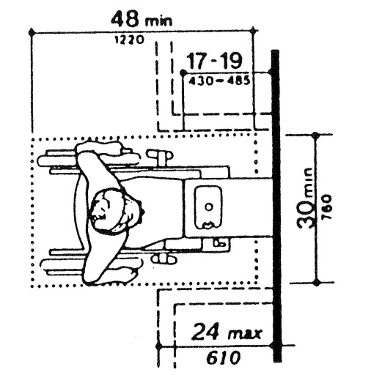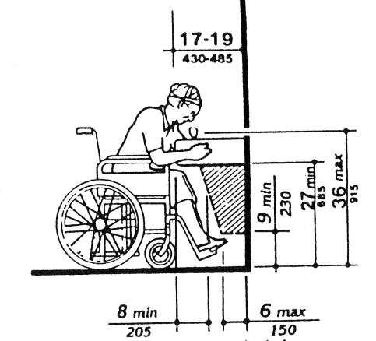
- Is there a clear floor space of at least 30 inches by 48 inches provided for a forward approach to the drinking fountain? (Fountains without knee clearance can provide a parallel approach.) Yes No N/A
- Is a knee clearance at least 27 inches above the floor provided at the front edge that extends back from the front edge at least 8 inches? Yes No N/A
- Is the spout mounted at the front of the unit? Yes No N/A
- Is the spout mounted no more than 36 inches above the floor? Yes No N/A
- Is the operating control mounted at the front of the unit or on the side near the front of the floor?
Yes No N/A
- Is the water flow at least 4 inches high in a trajectory parallel or nearly parallel to the front of unit?
Yes No N/A
- Do 50% of the drinking fountains per floor comply with questions 1-6 above? Yes No N/A
- Do 50% of the drinking fountains per floor have a spout height between 38 inches and 43 inches above the floor?
Yes No N/A
- If there is only one drinking fountain on the floor, does it have both a high and a low spout? Yes No N/A
- Does the drinking fountain protrude more than 4 inches from the wall between 27 inches and 80 inches above the floor? Yes No NA

INFORMATION KIOSK AND AUTOMATED TELLER MACHINE
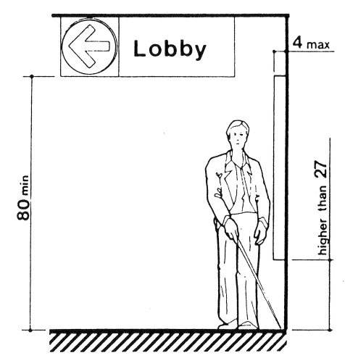
- Is a clear floor space 30 inches wide by 48 inches long provided next to the kiosk? Yes No N/A
- Are the controls located no more than 48 inches above the floor? Yes No N/A
- Are all operating controls and mechanisms operable with one hand without tight grasping, pinching, or twisting of the wrist? Yes No N/A
- Do all operating controls and mechanisms operate with no more than 5 lbs. of force? Yes No N/A
- Are all instructions and information accessible to and independently usable by persons who are blind or have limited vision? Yes No N/A

SALES AND SERVICE COUNTERS
- Do sales counters and counters for distribution of goods or services have a portion of the counter at least 36 inches wide that is no more than 36 inches above the floor? (does not apply to check-out aisles) Yes No N/A
- Are accessible counters dispersed throughout the facility? Yes No N/A
- Are the accessible counters located on accessible routes? Yes No N/A
- Are accessible check-out aisles identified with the international wheelchair symbol mounted above the check-out aisle in the same location as the check-out number or type of check-out? Yes No N/A
- Does the number of accessible check-out aisles provided comply with Table A below? Yes No N/A

Table A: Sales and Service Counters
Check-out Description | Number of each function | Accessible Check-out Description | # of Required Accessible Checkout Aisles
If the total number of check-out aisles of each function is | 1 to 4 | The minimum number of accessible check-out aisles must be | 1
If the total number of check-out aisles of each function is | 5 to 8 | The minimum number of accessible check-out aisles must be | 2
If the total number of check-out aisles of each function is | 9 to 15 | The minimum number of accessible check-out aisles must be | 3
If the total number of check-out aisles of each function is | More than 15 | The minimum number of accessible check-out aisles must be | 3, plus 20% of additional aisles

RESTAURANT AND CAFETERIA
(These requirements are in addition to all other applicable requirements.)
- Are dining surface heights (tables and counters) between 28 inches and 34 inches above the floor (30 inch maximum height preferred)? Yes No N/A
- Do dining surfaces have a minimum knee clearance of 27 inches above the floor (29 inches preferred)?
Yes No N/A
- Does the knee clearance extend at least 8 inches beneath the dining surface (11 inches minimum preferred)?
Yes No N/A

- Does the dining surface have a minimum toe clearance that extends at least 17 inches beneath the dining surface at a height of 9 inches above the floor? Yes No N/A
- Are the knee and toe clearances at least 30 inches in width? Yes No N/A
- Are accessible dining surfaces located on an accessible route that is a minimum of 36 inches wide?
Yes No N/A
- Are a minimum of 5% of the dining surfaces in compliance with questions 1-6 above? Yes No N/A
- Are all dining areas, including raised and sunken areas and outdoor areas, located on an accessible route? (In non-elevator buildings, mezzanine seating areas that provide less than 25% of the total dining seating are not required to be located on an accessible route.) Yes No N/A
- Are tray slides no more than 34 inches above the floor? Yes No N/A
- Does the food service line have a minimum clear width of 36 inches (42-inch preferred)? Yes No N/A
- Are the condiments and tableware located within the reach ranges shown in the diagrams below?
Yes No N/A

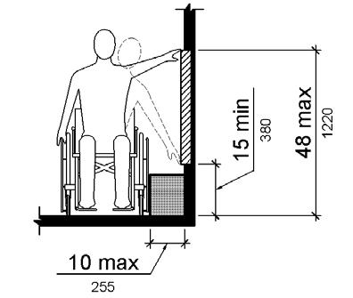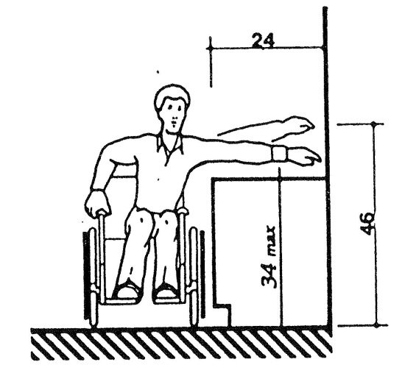
- Are the vending machine controls easy to operate requiring no tight grasping, pinching, or twisting of the wrist?
Yes No N/A
- Are the vending controls located no more than 48 inches above the floor? Yes No N/A

September 2016

