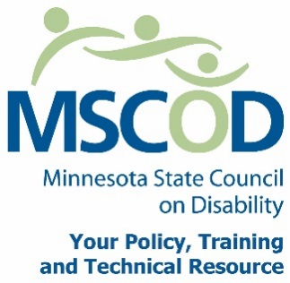

MSCOD Council Meeting Agenda
Thursday, September 29, 2016
10:00 a.m. to 2:00 p.m.
THERE IS A CHANCE OF AN ALTERNATIVE MEETING LOCATION.
If there is a change, Shannon will send the information out and directions prior to the meeting. SH
MSCOD
121 East 7th Place Suite 107
St. Paul, MN 55101
PLEASE plan to attend IN PERSON
10:00 a.m.: Call to order (5 min).
ACTION: Approval of Agenda and ACTION: Approval of Minutes
10:05 a.m.: New member introductions (10 min).
10:15 a.m.: Committee Organization (30 min).
BREAK OUT: COMMITTEE MEETING BY GROUP TO PLAN DATE AND TIME
10:45 a.m.: Legislative Update (20 min).
2017 Public Policy Priorities Discussion
11:15 a.m.: Executive Committee Nominations Committee (30 min).
11:35 a.m.: MN State Fair updates (15 min).
11:50 a.m.: Break (45 min).
12:35 p.m.: Legacy Updates (15 min).
12:50 p.m.: Strategic Plan update (40 min).
1:30 p.m.: Chairs report (10min).
Budget update
Executive Director’s report (10 min).
Other Business (5min).
Public Comment (5min).
2:00 p.m.: Adjourn
This document is also available in accessible formats.

