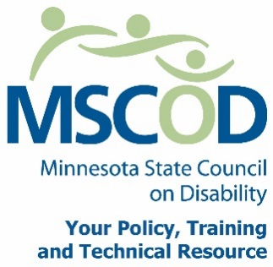

MSCOD Council Meeting Agenda
Thursday, December 1, 2016 10:00 a.m. to 2:00 p.m.
MSCOD Lower level room 2
121 East 7th Place Suite 107
St. Paul, MN 55101
PLEASE plan to attend IN PERSON
10:00 a.m.: Call to order (5 min).
ACTION: Approval of Agenda and ACTION: Approval of Minutes
10:05 a.m.: 2017 Public Policy Agenda (115 min).
- Speakers from partner agencies on key issues:
  - Susie Schatz: Lutheran Social Services MN/MNCCD
  - Heidi Hamilton: DHS
  - Leili Fatehi: Self-driving US
  - Randy Morris: Physical Therapists Association
- Staff presentations on MSCOD issues:
  - Joan Willshire
  - Margot Imdieke Cross: update on TAAC
  - George Shardlow
  - Linda Gremillion
12:00 p.m.: Break (45 min).
12:45 p.m.: Committee Updates (10 min).
12:55 p.m.: Executive Committee Nominations Committee (35min).
1:30 p.m.: Chairs report (10min).
Budget update
Executive Director’s report (10 min).
Other Business (5min).
Public Comment (5min).
2:00 p.m. Adjourn
This document is also available in accessible formats.

