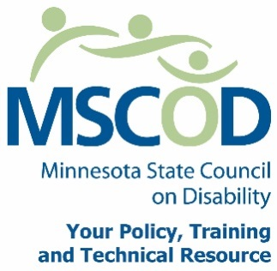

MSCOD Council Meeting Agenda
Thursday, January 26, 2017
12:00 p.m.to 2:00 p.m.
MSCOD Conference Room
121 East 7th Place Suite 107
St. Paul, MN 55101
Please plan on attending via conference line.
Main line phone number: 1-888-742-5095
Pass code 2854189640
12:00 p.m.: Call to order (5 min).
ACTION: Approval of Agenda and ACTION: Approval of Minutes
12:05 p.m.: Public Policy update (20 min).
12:25 p.m.: Legislative Budget (5min).
12:30 p.m.: Committee Planning Organization (15 min).
Executive Committee
Executive Nominations Committee
Access
Employment
12:45 p.m.: ADA Title III Training (60 min).
1:45 p.m.: Chairs report (5min).
Executive Director’s report (5 min).
Public Comment (5min).
2:00 p.m.: Adjourn
This document is also available in accessible formats.

