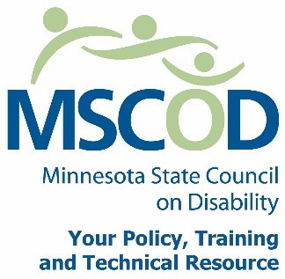

MSCOD Council Meeting Agenda
Thursday, October 5, 2017 10:00 am to 2:15 pm
Metro Square Lower Level Room 2
121 East 7th Place St. Paul, MN 55101
10:00 am: Call to order (5 minutes).
ACTION: Approval of Agenda and ACTION: Approval of Minutes
10:05 am: Welcome and Introductions (5 minutes).
10:10 am: Staff Presentation: Agency review for 2017 (10 minutes).
10:20 am: Agency Presentation, Moving Forward 2018 (15 minutes).
10:35 am: Website/branding update, Sarah and Chad (15 minutes).
10:50 am: Break (10 minutes).
11:00 am: Presentation: State Olmstead Specialty Committee,
Nancy Fitzsimmons (50 minutes).
11:50 pm: Break (45 minutes).
12:35 pm: Committee Updates (15 minutes).
State Fair Update, David and Linda
Access, Margot and Nate
Employment, Joan
12:50 pm: AMPERS RADIO PRESENTATION (10 minutes).
1:00 pm: Ex-Officio Presentations (10 minutes).
1:20 pm: Mission, Vision and Values Recommendations (15 minutes).
1:35 pm: Presentations: 700 hour Plan, EO-14-14 (20 minutes).
1:55 pm: Chairs report (10 minutes).
Executive Director’s report (5 minutes).
Public Comment (5 minutes).
2:15 pm: Adjourn
This document is also available in accessible formats.

