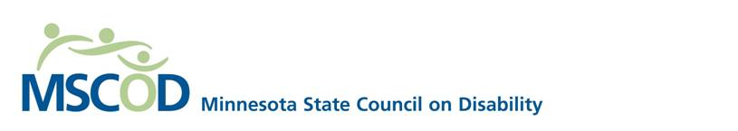

The Minnesota State Council on Disability is requesting Legacy funds to build upon previous work, honoring the legacy of Minnesota’s unique role in the passage of the Americans with Disabilities Act.

* **Staffing funds to oversee Legacy projects (0.8 FTE)-$154,000 biennial total**
  + Grant Administrator Sr. ($77,000/year includes fringe) to:
    - Work with MN History Center on ADA programming
    - Administer grant reporting
    - Administer procurement for activities
    - Administer work with Disability Viewpoints
* **Community outreach-$20,000 biennial total** 
  + “Disability Viewpoints” on Metro Channel 6
    - Broadcasting fee: $1,000
    - Captioning: $9,000
  + “Disability Viewpoints” on CTV
    - Broadcast fee: $10,000
* **ADA Celebrations throughout the State, 4-6 events outstate-$60,000 biennial total** 
  + $10,000 per location x 6 = $60,000
    - Accommodations (ASL, CART, etc.): $2,000 per location
    - Speakers $350 x 2 per location: $700 per location
    - Administrative fees: $3,600 per location
    - Entertainment $400 x 3 per location: $1,200 per location
    - Light refreshments: $1000 per location
    - Location/facility: $1,500 per location
* **Metro-area ADA celebration, in partnership with the Minnesota History Center: $10,000 biennial total**
* **Graphic design and printing for Metro and Statewide events: $5,000 biennial total**

**TOTAL: $249,000**