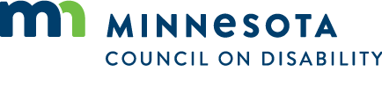

Policy and Monitoring Frameworks Committee Agenda
Tuesday, November 17, 2020
2:00 pm-4:00 pm
Location: 121 East 7th Place, St. Paul MN 55101
Via Zoom
As provided by MN Stat. 13D.021, the meeting with be held electronically.

- Meet and greet:
  - Name, organizational affiliation, and what about this sub-committee got you interested in participating in this group
  - Optional second question for fun: first or favorite movie or music album you bought as a kid
- Re-read the committee’s responsibility (broken up by task):
  - In order to set clear expectations for the staff and fulfill oversight responsibilities,
  - take lead developing written framework of organization directives (expected results and situations to avoid)
  - and system for monitoring that the organization met those directives.
  - Lead Advance Session group through framework review and approval process.
- What to do with the bylaws?
- Where do HR and State policies or laws work with these policies?
- This is different than the Accountability work which is about being accountable to our external stakeholders (community members, organizations, etc.).
- Brainstorming and discussion:
  - What are things that worry you?
  - What kinds of things do you need to see or have reported on to feel like you have proper oversight?
- Next steps: Take those items from 6 and translate them into potential policies for the full Council Board to react to.

