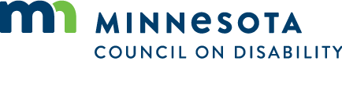

Special Full Council Meeting
September 3, 2021
9:00 to 11:00 am
Agenda
- Open meeting
- COVID data update
- Masking letter, Full Council discussion for support
- Request to join lawsuit regarding masking.
- Adjourn

