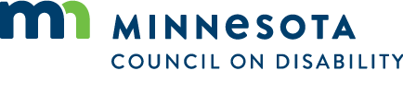

Stakeholder Feedback Survey Results
Organizations/Committees that responded:
- Multicultural Autism Action Network
- Minnesota Governor's Council on Developmental Disabilities
- DHS – Department of Human Services
- The Arc, MN
- Governor's Council on Mental Health
- SRC
- NAMI Minnesota
All were Familiar with MN Council on Disability:
Ways the heard of the council:
- Worked with or participated at an event sponsored by
- Through their current position or board membership
What does MCD do well:
- Leadership within the disability community
- Issues around access and accessible parking
- Advocacy
- Policy
What are areas of growth or opportunity for MCD from your perspective:
- Outreach to underserved populations
- Collaboration on key priorities
- Use Interactive multimedia to translate stories of barriers, voting, legislative process etc.
- Educate State Agencies, other boards and councils across the state
- Continue to address barriers
What should MCD emphasize or prioritize:
- All disabilities
- Collaboration
- Visibility to General Population
- Underrepresented populations

