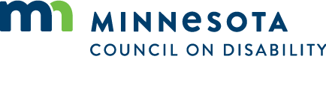

Full Council Meeting Agenda
Note: Following Open Meeting Law, 13D, this meeting is held fully electronically due to the health pandemic of COVID-19
June 8, 2022
2:00 to 4:00 pm
2:00 pm: Call to order by Chair (5 minutes)
ACTION: Approval of Agenda with majority vote
ACTION: Approval of Minutes April 12, 2022
2:05 pm: Welcome new member and introductions by Chair (5 minutes)
Nimo Ahmed- Region 11, Hennepin County.
2:10 pm: Membership Business (5 minutes)
Committee appointment for new member
2:15 pm: External Relationships Committee Update (20 minutes)
Discussion – Dawn Bly, Leigh Lake and Judy Moe
2:35 pm: Governance Systems Committee-led discussion (30 minutes)
3:05 pm: State Fair Planning Update (15 minutes)
3:20 pm: Financial Report (10 minutes)
3:30 pm: Staff Reports (15 minutes)
3:45 pm: Executive Director Report (10 minutes)
3:55 pm: Public Comment (5 minutes).
4:00 pm: Adjourn
Link: Zoomgov
Passcode: 783290

