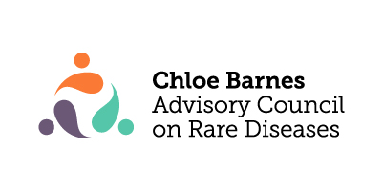

Meeting Minutes: Policy Committee
Date: Tuesday, November 15, 2022
Location: virtual

Attendance
Workgroup Members
Council Member | Attendance
Dawn Stenstrom | present
Sheldon Berkowitz | present
Karl Nelsen | present
Lisa Schimmenti | Present, joined at 4:43
Amy Gaviglio | Absent
Barbara Joers | Absent
Members of the Public: none
Meeting called to order at 4:03

Policy initiatives currently happening, state level
Discussed the Network Access Bill. Sheldon- we do not want to take the lead, but can come out in support of it. Proposed deliberative process: policy committee make a recommendation to the executive subcommittee who then determines official endorsements. If policy or executive subcommittee will be determining policy actions this needs to be explicitly given to the committee by full Council in operating procedures. Sheldon proposed that. Some things need immediate action so to executive subcommittee can more quickly act, some controversial items should go to entire Council. Re: Network Access Bill, Erica will communicate with Gillette and Rep Reyer for the following:
- presenting-are they in support of us doing this?
- Can explicit wording be added for out of state coverage?
- What kind of opportunities will we have to give input? Can Marnie give a general presentation on the bill to the policy committee?

Opportunities for engagement
Invitation to present at Minnesota Council on Disability Policy Forum in December. Will discuss with Marnie Falk
Requests for endorsements (PAGS) | Council generated legislation | providing technical assistance and input on draft legislation

Decision points
When considering bills: Is it in the best interests of the RD community? Discussed committee need to determine rule of engagement with patient groups, policy makers. Deliberative process needs to be established/consensus for how we will determine which bills we will support. Discussion around state and federal policy and how to address both since both are included in legislation. Reaching out to NORD and sending letter of introduction for the Council to federal legislators was proposed.

Action items:
- Outline which items need to go to ESC vs to full Council- policy committee next meeting
- Request Marnie to present on Network Access Bill- Erica
- Consensus, guiding principles established- policy committee in next meeting, members to work ahead of time and bring proposals
- Regular meeting times- Every 3rd Tuesday 4-5 monthly till June
- Reach out to federal legislators with an RDAC introduction- Erica

